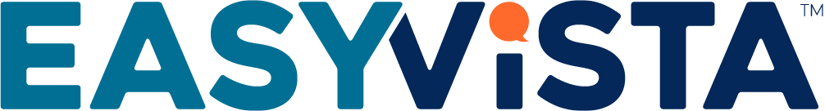 Job Description
Software Engineer – C++
Goverlan, an EasyVista company, is the top-rated IT Endpoint Management solution which specializes in the creation of remote system management software for enterprise IT and MSPs. Our flagship product aims at supporting all network device types and platforms, including Windows, Mac OS, Linux, iOS and Android.
Our service delivery platform is built to support both self-hosted and hosted offerings via on-site client-server implementations, and cloud-based SaaS.
We are looking for mid-to-senior level C++ software engineer/developers, who can handle complexity, with a clear and calm intellectual demeanor. This high-impact position requires the understanding and love of clean code and architecture.

Key Responsibilities:
You will be working with a small team of sharp developers to continue the improvements and add new features to our flagship product. Your development skills will be focused on many aspects of programming from UI, to middle or back tier, from operator side, to client side to server-side programming. You will be exposed to intellectual challenges and will learn new technologies.
This is a very exciting position!
Desired Skills and Experience:
- Strong knowledge of C/C++, STL (required)
- Strong knowledge of MacOS API (optional)
- Knowledge of Windows API (optional)
- Knowledge of Linux API (optional)
- Strong experience with multi-threaded and multi-process applications
- Experience working with BSD/POSIX sockets and TCP/IP a plus
- UI/UIX development a plus

Full-time, exempt, 40+ hours per week
Salary: $85,000 to $120,000 Annually
Benefits: Dental, Medical, Vision

